Task -3 DNS(Domain Name system) System.
1. Install BIND9 DNS server on your Linux machine and verify the installation by checking the version with the named -v command.
Note: All the commands are in the Screenshot below
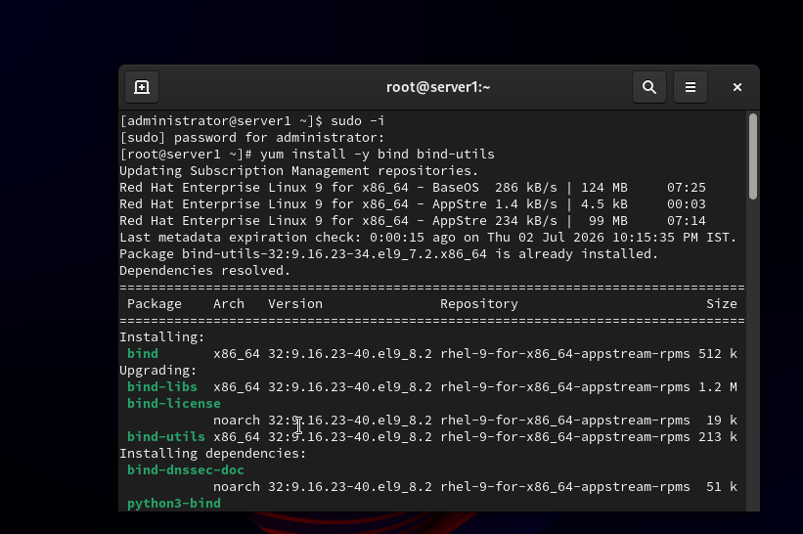
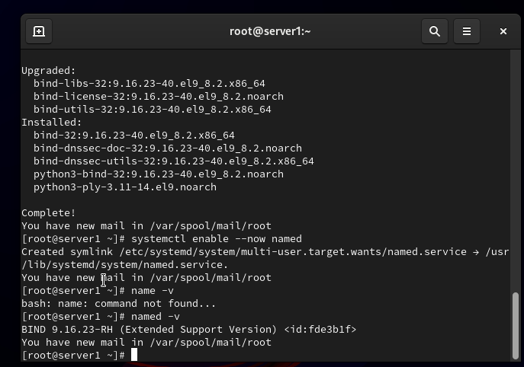

2. Configure a basic DNS zone file in /etc/bind/ for a custom domain like myzomatoclone.local, mapping it to 127.0.0.1, and restart the DNS service to apply changes.<br><br><em><strong>Hint:</strong> Edit named.conf.local and create a new zone file using db.local as a template.</em>
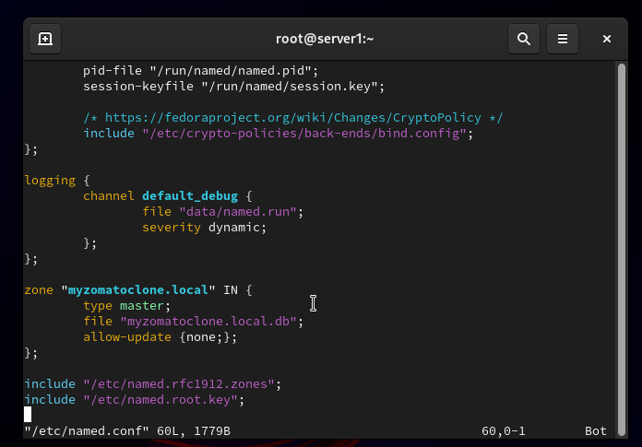
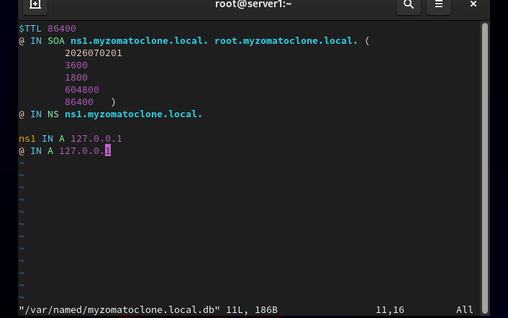
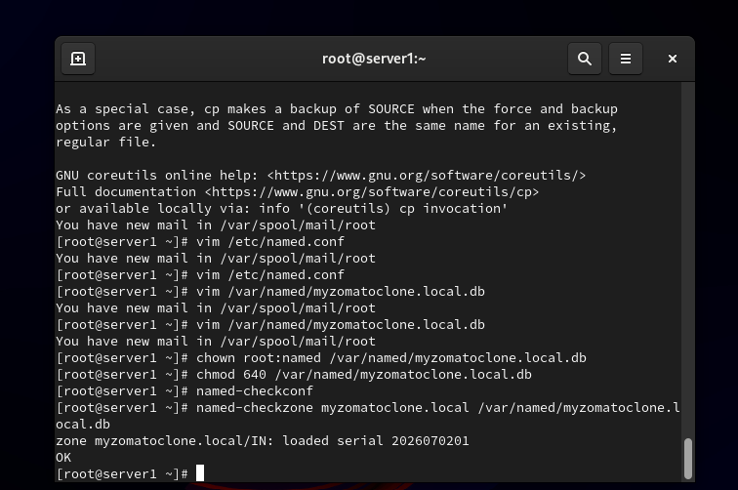

3. Configure Local DNS Resolver
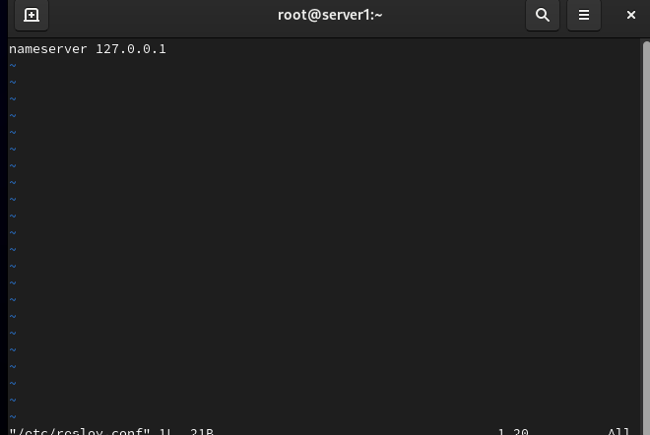
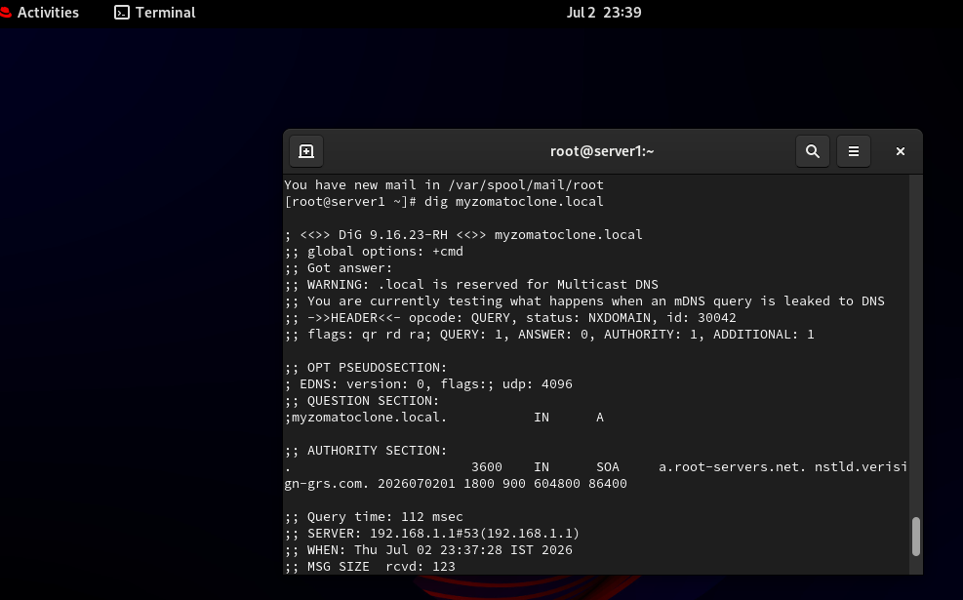

4. Add a CName Record
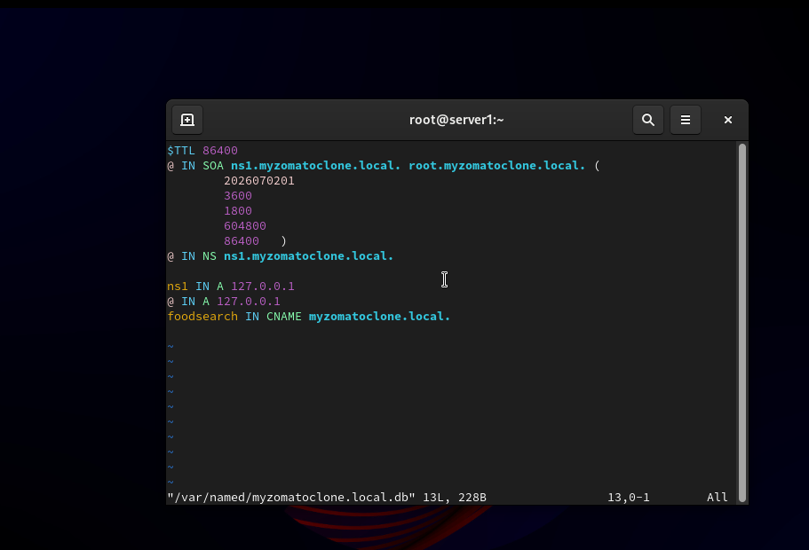
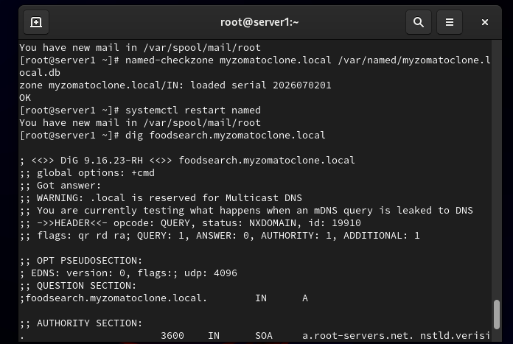

5. Final verification.
